

3 epochs newBalancedData:

51%

5 epochs newBalancedData:

47%



3 epochs newBalancedData:

51.2%

5 epochs newBalancedData:

58%



3 epochs newBalancedData:

62%

5 epochs newBalancedData:

51%

NEW TEST ON CONSTRAINING PROBABILITY:



Np argmax

<0.6

<0.55

<0.52

<0.57

Testing other transformers with test dataset:

Hate-speech-CNERG/dehatebert-mono-english

mrm8488/distilroberta-finetuned-tweets-hate-speech

Hate-speech-CNERG/bert-base-uncased-hatexplain

Narrativaai/deberta-v3-small-finetuned-hate_speech18

Sakil/distilbert_lazylearner_hatespeech_detection

monologg/koelectra-base-v3-hate-speech

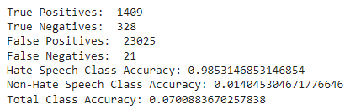

Testing other transformers with train dataset:

Hate-speech-CNERG/dehatebert-mono-english

mrm8488/distilroberta-finetuned-tweets-hate-speech

Hate-speech-CNERG/bert-base-uncased-hatexplain

Narrativaai/deberta-v3-small-finetuned-hate_speech18

Sakil/distilbert_lazylearner_hatespeech_detection

monologg/koelectra-base-v3-hate-speech

